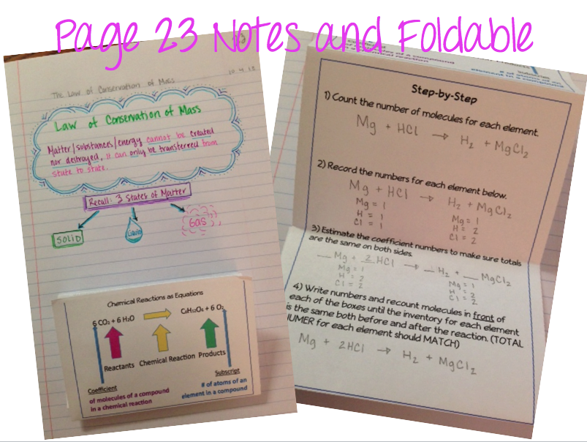

**Write It!** Copy the notes onto your File Folder and on your foldable.

Glue onto your File Folder. (See my example for Size and Location!)